Index

1. Introduction 3
2. Energy Balance of Buildings 3
Internal Heat Gain (Q_{i}) 5
Solar Heat Gain (Q_{s}) 5
Conductance (Q_{c}) 6
Ventilation (Q_{v}) 6
Evaporative Heat Loss (Q_{e}) 6
Mechanical Controls (Q_{m}) 6
Habits 7
Energy Consumption during the Life Span of House 7
3. Energy Regulations for Buildings 8
Building Recommendations 8
The Singapore Experience 9
Potential for Energy Savings in Buildings 9
4. Thermal Comfort Zone 10
Fanger 11
Zain Ahmed 11
Davis 11
Summary of Studies 12
5. Computer Tools 12
U-value 13
Numerical Calculations 13
Heat2 15
TSBI3 17
6. Test Reference Year (TRY) 18
Weather Data from Subang 18
Weather data for TRY 18
Erbs’ Estimation Model for Solar Radiation 19
Selection of months for TRY 20
Part 1 20
Part 2 20
Part 3 21
Selection 22
Validation of TRY 25
7. Presentation of Houses 26
Terrace House 26
UPM Thermal Comfort House 29
Other low-cost houses 31
Malaysian Architecture 32
8. Measurements 33
Measuring Equipment 33
The Experiment 33
Results 34
Urbanisation Effect 34
Night Cooling 36
9. Simulations and Results 38
Roof and Wall Simulations (Heat2) 38
Computed U-values 39
Simulation for UPM Thermal Comfort House (TSBI3) 41
Roof-simulations in TSBI3 44
Simulations for Solar Heat Gain 45
10. Recommendations and Future Work 46
11. List of Abbreviations 47
12. References 47
13. Attachments 48

Introduction

The invention of air-conditioning can be regarded as the invention with the most profound influence in tropical countries. Never before had it been possible to live in complete thermal comfort. Prior to the emergence space cooling units Malaysians were obliged to adjust their way of living to the climate. With air-conditioned indoor environments Malaysians have adopted lifestyles largely indifferent to the climate. Unfortunately, the same climatic indifference applies to many recent house designs resulting in unreasonably large energy expenditures for air-conditioning. There is much energy and much money to be saved by employing climatic design principles, i.e. adjusting the building to the climate. The potential for energy savings can be determined rather accurately through the use of computer simulations. Two such programs, Heat2 and TSBI3, will be presented in this report and used for calculations and simulations on a prototype low-energy house built at the Centre for Thermal Comfort Studies at Universiti Putra Malaysia. Actual temperature measurements from the house are also included in the report.

The major work of this study was the construction of a Malaysian weather-data-year – or TRY (Test Reference Year) – for the TSBI3 simulation. The TRY, which is constructed from 21 years of hourly weather data from Subang Meteorological Station, was only finished two weeks before the report deadline. Hence, the TSBI3 building simulations are not very elaborate for this report. However, more simulations and in depth analysis will be presented in a new report in June 2000. The report will also include simulations for one or two different houses for the sake of comparison.

The four month project period in Malaysia has been eventful (see project diary in attachment 1). The co-operation with the Kuala Lumpur Danced-office proved to be very fruitful. The same can be said about the co-operation with other Malaysian universities through which a good network was established. During the stay in Malaysia three papers were written in addition to this report. Two of the papers were presented at separate seminars in Malaysia, while the last paper was submitted to the World Renewable Energy Congress to be held in England later this year. A seminar was also co-organised with supervisor Mohd. Peter Davis; the seminar program is found in attachment 2.

Energy Balance of Buildings

A prerequisite for undertaking energy savings in building is a thorough understanding of the mechanisms, which influence the energy balance of houses. This chapter will describe each of the mechanisms individually - the outset being the illustration in Figure 1 displaying the various heat flows for buildings. The aim of subsequent chapters will be to determine the magnitude of each heat flow in order to reveal the potential for energy savings.

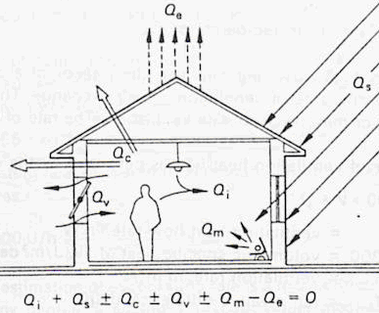
Figure 1: Energy balance for house (Koenigsberger, 1973).

The formula in Figure 1 is described in greater detail below:

$$Q_{i}+Q_{s}±Q_{c}±Q_{v}±Q_{m}−Q_{e}=0$$ | Equation 1
$$\begin{aligned}\text{where} \\ Q_{i}=\text{Internal heat gain }(\text{human bodies, lamps, appliances etc}\text{.}) \\ Q_{s}=\text{Solar heat gain through windows} \\ Q_{c}=\text{Conduction of heat through walls, roofs and foundation} \\ Q_{v}=\text{Heat exchange by ventilation} \\ Q_{m}=\text{Heat removal/supply by mechanical controls }(e\text{.}g\text{.}\text{ air-conditioner and heater}) \\ Q_{e}=\text{Evaporative cooling from building surface }(e\text{.}g\text{.}\text{ a roof pool})\end{aligned}$$

All the respective heat fluxes in Equation 1 must add up to zero to maintain the desired indoor temperature. If the heat fluxes add up to a positive number the temperature of the house will increase and vice versa. Figure 1 applies to all climates as the heat transfer by conductance (Q_{c}), ventilation (Q_{v}) and mechanical control (Q_{m}) can be both positive and negative. The outdoor climate and usage of the house are constantly changing, and the indoor temperature will therefore vary accordingly. The aim of low-energy houses is to keep the temperature variations within the comfort zone of the occupants at a minimal (energy) cost – i.e. minimising Q_{m}.

Internal Heat Gain (Q_{i})
The internal heat gain stems from all heat emitting objects within the house. This includes human beings, lamps and other electric appliances like refrigerators, freezers, microwave ovens, fans, televisions and computers.

Human beings emit about 100 Watt when awake and 50 Watt while asleep (Fanger, 1992). The internal heat contribution of electric appliances equals their wattage. A 100-Watt incandescent lamp will, for example, give off 95% of the energy as heat, while the remaining 5% energy emitted as light will convert into heat when reaching the surfaces of the room.

Fans, refrigerators and freezers are often thought, mistakenly to have a chilling effect on the room, but quite contrary they help to heat up the room in accordance with the principle of conservation of energy. Thus, the internal heat gain corresponds once again to the wattage of the appliances.

For cold climates the internal heat gain is welcomed as it contributes to the heating of the house, whereas for warm climates the internal heat gain must be minimised because additional heating of the house is undesirable. The benefit of decreasing the electrical internal heat gain in warm climates is therefore twofold:

- The electricity (cost) for the appliances is reduced.
- The electricity (cost) for removal of the internal heat gain is reduced.

Example: Energy Efficient Ceiling Fan
Ceiling fans are found in the vast majority of the households in warm and humid climates. Compared to air-conditioning units, fans are much cheaper to acquire and to operate. However, a study at the Florida Solar Energy Centre has shown that ceiling fans with aerodynamic blades compared to conventional ceiling fans use 50% less energy and reduce levels of noise and wobble (Parker, 1999). The potential for further energy savings is considerable as the shaded pole motors used in conventional ceiling fans are highly inefficient (0.026 < η < 0.13). Thus, there exists a big potential for reduction of internal heat gain from fans; it seems logical to improve the efficiency of fans because the wasted energy acts counter to the sole purpose of using them.

Solar Heat Gain (Q_{s})
The solar heat gain takes place when direct and diffuse sunlight is allowed to pass through windows. It is desirable to reduce this heat gain in warm and humid climates, either by blocking out the sun by shading devices or by applying special window coatings that only allow the visible light – and not the UV and infrared light – to penetrate.

One has to be careful not to block out too much of the daylight as this will increase the demand for artificial lighting, which also will heat up the house. Moreover, the artificial lighting has to be paid for whereas daylighting is free.

Conductance (Q_{c})
Conductance of heat through walls, roof and foundation can go both ways – even in warm and humid climates, where the night temperature falls below the indoor temperature. The conductance in warm and humid climates will be most notable through structures that are exposed to sunlight and therefore experience a high temperature gradient. This applies mainly to the roof and to the East and West facing walls.

Ventilation (Q_{v})
The indoor air must be ventilated in order to stay fresh. If the outdoor air temperature is hotter than the indoor temperature it will help to heat up the indoor climate. If the outdoor air on the contrary is cooler it will have a chilling effect. The dinural temperature variations of the outdoor air can for some climates be used advantageously to influence the energy balance of the house via appropriate ventilation schedules.

Heat gain/loss from ventilation can be reduced considerably by the use of ventilation using heat recovery units. This especially applies for very cold and very hot climates with a substantial difference between outdoor and indoor air temperatures.

Evaporative Heat Loss (Q_{e})
The evaporation of water from building surfaces or people (sweat) and a subsequent removal of the water vapour will exert a cooling effect. The latent heat of evaporation (water, 20°C) is approx. 2400 kJ/kg, but it is often difficult to determine the rate of evaporation and thus the exact cooling effect caused by evaporation.

Mechanical Controls (Q_{m})
The mechanical controls make the energy balance for the house reach zero (Equation 1). For cold climates the mechanical controls (heating units) will deliver the final heat contribution for the houses to stay comfortable whereas for warm climates air-conditioning units will remove excess heat from the indoor climate. The usage of mechanical controls is thus dependent on all the above heat flows, which again are dependent on the house design and on the habits of the house residents. Houses that stay thermally comfortable with small energy consumption for mechanical controls are called low-energy houses.

Habits
Studies have shows that the habits of the house residents can cause considerable variations in the energy consumption (up to 100%) of identical houses. The reason being different usage patterns of the house. Some inhabitants may spend a lot of their time in the house while some might not (e.g. eating out). Some like cooler indoor temperatures than others do. Some use a lot of electrical equipment, while others do not. And finally, some have energy conscious behaviour (e.g. turning off the lights when leaving a room) while others do not. This “energy conscience” may be pushed by economical incentives, i.e. the desire to get a low energy bill by the end of the month. Three examples of markedly different household habits are given below. The three Malaysian households are compared with an average Malaysian household.

EXAMPLE: Comparison of different households in Malaysia (C=average household)
- Scandinavian family (4 persons) with two local maids living in big bungalow.
- English-Malay family (5 persons) with one local maid living in big energy efficient bungalow.
- Average Malaysian family (4.8 persons) living in terrace house (Loke, 1999).
- Five “poor” Malaysian students sharing an apartment flat.

Household  (in Malaysia) | No. of  people | Energy efficient  home | Indoor  temperature | Use of  air-conditioner | Electric appliances | Monthly electricity consumption
A | 6 | no | cool | yes | many | 8160 kWh
B | 6 | yes | medium | no | average | 406 kWh
C | 4.8 | no | medium-hot | no | average | 300 kWh
D | 5 | no | hot | no | few | 118 kWh

Energy Consumption during the Life Span of House
To get a truthful picture of the energy performance of a house it is necessary to sum up the energy used throughout the life span of the house including the energy spent for its construction (embodied energy) and disposal. These computations can be rather laborious and associated with uncertainty. It is not the scope of this report to elaborate on the topic of life span energy for houses apart from noting that approx. 2/3 of the total energy is spent when the house is in use (Fausi, 1999). Hence, the biggest potential for energy savings lies in the design of the house to minimise the operational energy demand.

Energy Regulations for Buildings

There is not much to say about this topic because Malaysia does not have any energy regulations for buildings. The Malaysian building regulations are stated in the UBBL (Unified Building By-Laws), but they do not address any energy issues for buildings. The current UBBL is 15 years old; it needs to be updated and to include mandatory energy standards (Fong, 1999).

Building Recommendations
In warm and humid climates the outdoor air temperature only varies slightly (ΔT ≈ 10°C) from day to night. The building structures of high thermal mass do not cool sufficiently at night to act as an effective heat buffer during the day. Instead, building structures exposed to sunlight overheat. The principle of thermal storage can therefore not be used to achieve indoor thermal comfort. Thus, buildings are advised to be constructed from lightweight materials with low thermal mass. Moreover, constructions exposed to sunlight should be insulated and have a reflective surface (Koenigsberger et al., 1973). Figure 2 shows the reflective and emissive properties for different surfaces; the best surfaces properties are high solar reflectance and high heat emissivity, both are found in the top left hand corner (Cler et al., 1998).

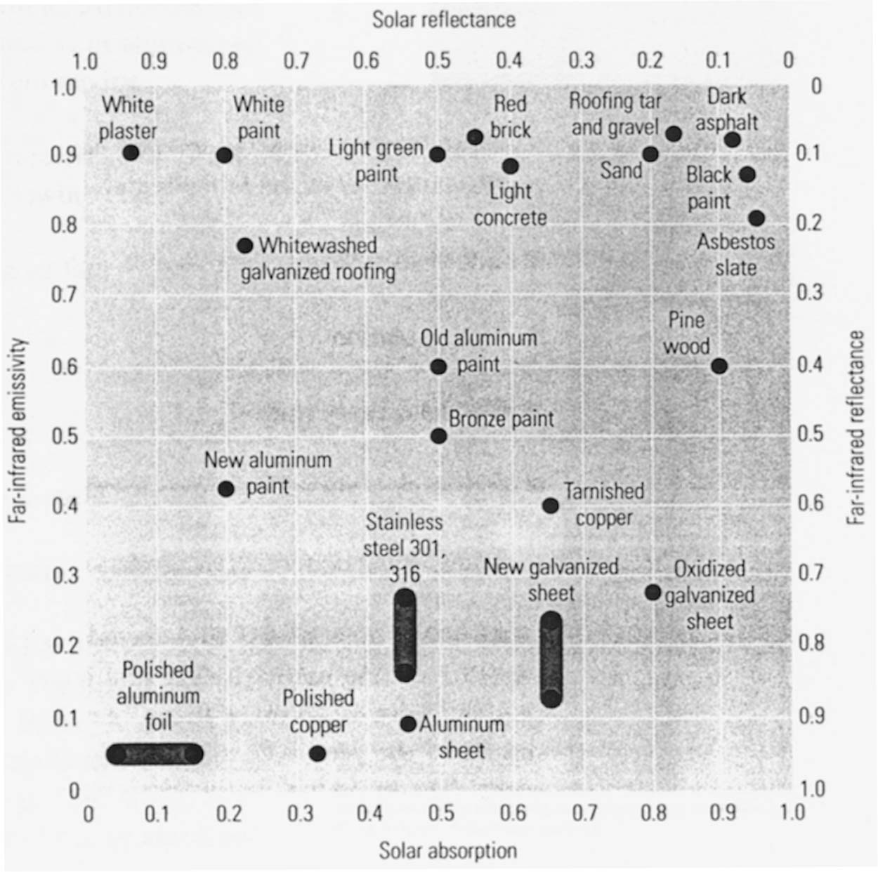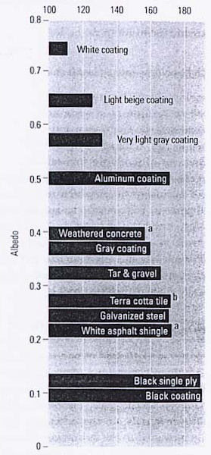
Figure 2: 1) Properties for solar reflectance and far-infrared emissivity 2) Temperatures for different surfaces at clear sky conditions in Texas with an ambient temperature of 90°F (32°C). The temperature scale runs from 100°F (32°C) to 190°F (87°C). Both figures are from (Cler et al., 1998).

The Singapore Experience
Energy regulations for buildings have been strictly enforced in the neighbouring country Singapore since the 1970’s. Malaysia has often looked to Singapore during both of the countries’ rapid economic development over the past decades. It seems sensible for Malaysia to adopt the energy regulations of Singapore as both countries have a very similar climate.

The energy regulations in Singapore only apply to air-conditioned buildings. A design criterion – the OTTV (Overall Thermal Transfer Value) – is applied to the building envelope. The idea is to set a maximum level for the heat gain through the building envelope (walls, roof and windows) in order to reduce the cooling load. The maximum allowable OTTV is 45 W/m² floor area (Singapore Building Regulations, 1999). Table 1 lists some recommended maximum values for thermal transmittance (U-values) for compliance to the OTTV limit.

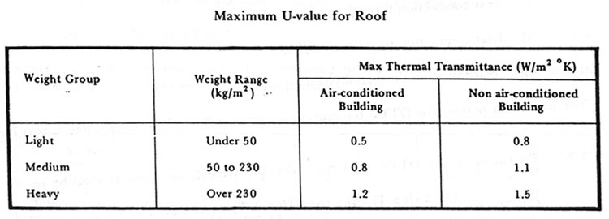
Table 1: Figure taken from (Singapore Building Regulations, 1999). An identical recommendation for lightweight roof structures is found in (Koenigsberger et al., 1973).

Potential for Energy Savings in Buildings
Integrated resource planning shows that it is five times cheaper to save energy in buildings (US$ 400/kW) than to increase the power production capacity (US$ 2000/kW) (Kannan, 1999). It is economically feasibly to save an estimated 40-50% of the energy in new buildings and 15-25% in existing buildings (Kannan, 1999). The potential for energy savings in buildings is no doubt present in Malaysia; however, the legislation and implementation strategies to harvest the savings are missing.

Example: The Danish Experience
Denmark has been very successful in attaining energy savings in buildings. The energy consumption for space heating pr. m² floor area has been reduced by 50% over the last 20 years. During this period the building codes have gradually become more stringent.
(Longhi, 1999)

Thermal Comfort Zone

A person attains thermal comfort when he is no longer aware of the ambient temperature. This happens within a temperature interval denoted as the comfort zone. The indoor climate should be kept within the comfort zone or else people will suffer mentally (lowered concentration levels, difficulties sleeping etc.) and physically (headaches, flues etc.). Both of which decrease the productiveness of people and their quality of life (Davis, 1999). Such violations of the thermal comfort zone are critical in Malaysia where people spend the bulk of their time indoors. The thermal comfort zone is therefore an important parameter when it comes to structural design of houses and projection of mechanical indoor climate control units.

Several thermal comfort studies exist seven of, which will be presented in this chapter. It is important to note that many factors influence the perception of the thermal comfort. (Fanger, 1992):

- clothing
- activity level
- air movement
- relative humidity
- air temperature
- radiant temperature

Moreover, local parameter variations like asymmetrical surface radiation (e.g. a hot ceiling) and fluctuations in air movement will also affect the thermal comfort (Fanger, 1992). Complicating things further is the fact that people are different and therefore not necessarily attain thermal comfort within the same temperature intervals. In fact, Fanger’s work shows that it is impossible to satisfy everyone at any given temperature.

Figure 3: (1) Percentage of people dissatisfied when the temperature of the surfaces are different. Note that people are most sensitive to a “Warm ceiling”, which is often found in the tropics. (2) The general level of dissatisfaction never reaches zero, i.e. people are different. (Fanger, 1992)

Fanger
P.O. Fanger has set the international standard for thermal comfort studies by quantifying all of the above parameters and putting them into a unified “thermal comfort equation”. This equation predicts the mean thermal comfort of people under any circumstances. The elaborate theory will not be presented here but can be found in the reference (Fanger, 1992). However, the thermal comfort zone for Malaysian clothing level is given in Table 2:

Table 2: Thermal Comfort Zone for Malaysians doing office work (Fanger, 1992).
Clothing (clo = 0.5) | Thermal resistance of clothing: 0.5 (m² K)/W  not correct | Light clothing (light pants, shirt with short sleeves, underwear, light socks, shoes)
Activity level (met = 1.2) | 70 W/(m² skin surface) | Office work, sitting down
Air movement | 0.2 m/s
Relative humidity | 80%
Thermal Comfort Zone | 24.5 – 26.5 °C

The thermal comfort equations by Fanger are based on climate chamber experiments of primarily university students from Denmark. To check whether the thermal comfort equations are versatile, Fanger has undertaken experiments with groups of elderly as well as foreign people (Japanese and North Americans). No significant deviation from his previous findings was detected, thus indicating versatility of his equations contrary to other studies that incorporate adaptive measures.

Zain Ahmed
This study was carried out on 300 Malaysian university students who were asked to fill out a questionnaires regarding their thermal comfort at the end of lectures. The average air movement and relative humidity was 0.3 m/s and 73%, respectively. The comfort zone was found to be 24.5 – 28.0 °C (Zain Ahmed, 1997). This study lists a number of other thermal comfort zone studies, which will be included in final section of this chapter.

Davis
The leader of the Centre of Thermal Comfort Studies at Universiti Putra Malaysia, Mohd. Peter Davis, has found the thermal comfort zone of Malaysians to be 24 – 28°C. This comfort zone is based on many years of surveys and experience within the field of thermal comfort studies.

Summary of Studies
This paragraph comprises seven thermal comfort studies, four of which have been carried out on Malaysians either in climate chambers or as field studies. The conclusions of the studies differ slightly due to different test procedures. However, most of the studies seem to agree on a Malaysian comfort zone around 25°C.

Table 3: Thermal comfort studies for sedentary activity (e.g. office work)
Study | Comfort Zone  [°C] | Type of study | Humidity  range  [%] | Air  movement  [m/s]
^{a)} Fanger | 24.5 – 26.5 | Climate chamber | 80 | 0.2
^{b)} Zain-Ahmed | 24.5 – 28.0 | Field study | 72 - 74 | 0.3
^{b)} Abdulmalik | 25.5 – 29.5 | Climate chamber | 45 – 90 | -
^{b)} Davis | 24 – 28 | Field study | - | -
^{b)} METP | 22.0 – 26.0 | - | - | -
^{c)} Brooks | 23.0 – 29.0 | - | - | -
^{d)} ASHRAE | 23.0 – 25.0 | - | - | -
^{a)} Danish study; light clothing (clo = 0.5)
^{b)} Malaysian study; light clothing (clo ≈ 0.5)
^{c)} English study; presumably light clothing (clo ≈ 0.5)
^{d)} North American study; presumably western office attire clothing (clo ≈ 1)

The comfort study used in the subsequent work of this report is that of Davis. In other words, the air conditioner set point is 28°C for all the computer simulations; a presentation of the different computer programs is given below.

Computer Tools

Computing the thermal performance of a building before it is even built has several advantages. It becomes possible in the pre-construction stages to refine the thermal properties for each building element. Moreover, correct dimensioning of mechanical control units (air-cons, dehumidifiers, heaters etc.) is feasible. Optimisation of the building design and mechanical control units makes it possible to attain indoor thermal comfort at sensible energy expenditures to the benefit of house owner and the environment.

Heat transmission occurs by conduction, convection and radiation. The analytical methods for heat transfer calculations do no suffice when it comes to complex composite structures with thermal bridging. Thermal bridging occurs when a material of relatively high thermal conductance penetrates a building structure. In this case, much heat will flow through the “thermal bridge”, thus increasing the thermal transmittance (denoted as “U-value”, see page 13) of the building structure. Just how much energy flows through the thermal bridge is difficult to determine with conventional analytical methods, but with numerical computer calculations it becomes possible. The computer program Heat2 can perform such calculations with a margin of error specified by the user. The U-value of the building structure is one of many outputs from the program. The annual heat flows through the building envelope can be calculated with another program, TSBI3; both programs are presented later in this chapter.

U-value
The heat transmission coefficient of a building structure is denoted as a U-value. For simple building structure with no thermal bridging the U-value is calculated by the following formulas:

U-value of building structure: | U=1/R | [W/m² K]
Thickness of material: | d | [m]
Thermal conductance: | λ | [W/m K]
Thermal resistance of building material: | r = d/λ | [m² K/W]
Total thermal resistance of building structure: | R=Σr | [m² K/W]
Heat transmission through building structure: | Q=(A)(U)(ΔT) | [W]
where A is area of the building structure  and ΔT is the temperature difference | A  ΔT | [m²]  [°C]

The formulas above to not suffice for more complex building structures experiencing an inhomogeneous heat transmission (i.e. occurrence of thermal bridging, radiation in cavities etc.). Another set of formulas does exist for more complex building structures, but the formulas are time consuming to use and do not reveal how the heat flow is distributed across the building structure. A faster and better method for heat transmission calculations is possible using computer programs that calculate the heat flow numerically.

Numerical Calculations
The principle of the heat transmission calculations of the computer program Heat2 will be described. The compound through which the heat transmission is to be calculated is divided into a mesh (see Figure 4).

Figure 4: Mesh applied to cross-section of roof structure for numerical heat transfer calculations in Heat2.

Each nodal point of the mesh represents the surrounding area, the size of which is determined by the density of the mesh. The nodal points carry information about the thermal properties of the material at any given time:

- Thermal conductivity [stationary]
- Heat capacity [stationary]
- Temperature [changing]

A temperature gradient across the material is established by defining the desired boundary conditions (e.g. roof temperature outdoors and indoors). The heat flux between each nodal point and its neighbouring four nodal points is calculated using Fourier’s law of heat conduction

$$\text{Heat flux}=−k\frac{\text{dT}}{\text{dx}} \left[W/m^{2}\right]$$

where k = thermal conductivity [W/m K]

After each calculation the temperature change of each nodal point depends on the net heat flow to or from the nodal point. The calculation continues iteratively until the temperatures of the individual nodal points have stabilised within the specified margin of error. The output specifies the heat flow through each boundary surface (e.g. indoors and outdoors), and the U-value of the building structure can be determined.

Heat2
This computer program can calculate two-dimensional heat flows through materials and air cavities or any combination of these. The program contains a large material library with thermal properties for different building materials; entering new materials is also possible.

Heat2 is an user- friendly window based program, but a few days of familiarisation are required. The results of the simulations can be displayed in a multitude of fashions – numerically as well as graphically. Both types can easily be transferred to Excel and Word. A roof structure with isotherms and boundary heat flows (q) is displayed in Figure 5. The U-value is determined by dividing the heat flow (10.3 W/m²) by the temperature difference across the roof (22°C) and is found to be 0.47 W/m² K.
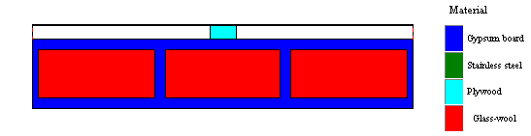

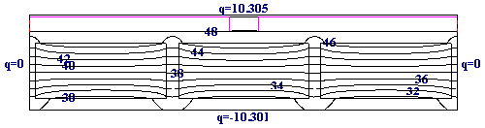
Figure 5: Isotherms and boundary heat flows [W/m²] for cross section of roof structure (RapidWall) with an outside temperature of 50°C and indoor temperature of 28°C. The length of the cross section is 810 mm.

The sum of the boundary heat flows in Figure 5 add up to zero (approximately) indicating that it is a steady-state calculation. In the real world a roof structure will not experience stationary boundary conditions, but they are needed for determination of the U-value.

The graphical display can be done in colour or using grey-scale. The latter has been used for Figure 6 and Figure 7.

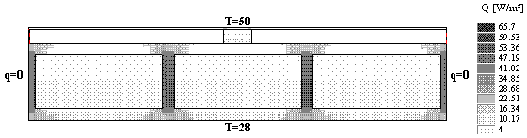
Figure 6: Heat flux (Q) is displayed in grey-scale. The dark patches show thermal bridging of the vertical fibre-gypsum fortifiers in the roof structure (see Figure 5). Please note that heat flux can not be displayed in the air cavity immediately under the metal sheet roof.

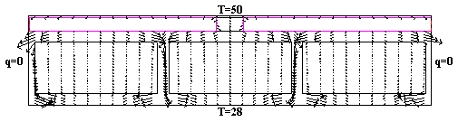
Figure 7: The magnitude and direction of the heat flux [W/m²] can be displayed by arrows. The magnitude is seen to be much greater through the fibre-gypsum than through the Glass-wool.

TSBI3
The computer program TSBI3 is useful when evaluating the indoor climate and energy conditions of buildings on an annual, monthly, daily or even hourly basis. The program is also a good tool when designing mechanical control units for establishment of indoor thermal comfort.

The input to TSBI3 is very detailed and encompasses the size measurements for the house and the rooms, the orientation of the house, the thermal properties of the building materials including windows, the internal heat gains and the ventilation rates to the outside and between the rooms. Moreover, the type of mechanical control units must be entered in the program together with their thermostat settings and operational schedules.

TSBI3 utilises a weather-data-year for the region where the building is located. The weather data are carefully chosen from a period of at least 10 years in order to be representative of the surrounding climate (see next chapter Test Reference Year (TRY), page 17).

The output from TSBI3 is very detailed; output relevant for this report is:

- Heat gains for solar radiation, persons, lighting and equipment
- Solar radiation through windows
- Cooling and ventilation
- Power and energy balance
- Temperature conditions
- Heat and air exchange between rooms
- Shade conditions

The program is somewhat difficult to use and may seem confusing to the untrained user. An improved version is soon to be released.

Test Reference Year (TRY)

A Test Reference Year (TRY) consists of annual weather data for a given location. In order for the TRY to be representative of the climate it should be constructed on the basis of at least 10 years of weather data. The TRY is made up from actual monthly data (not average values) that are picked after having been subjected to three different types of analysis. The analysis and construction of a Malaysian TRY (Subang, Klang Valley) will be given in the following.

Weather Data from Subang
The 21 years of weather data come from the Malaysian Meteorological Station in Subang, Klang Valley, Selangor. The meteorological station lies in a region that is experiencing urbanisation and socio-economic growth.

Table 4: Weather data obtained from Subang
Subang Meteorological Station
(Klang Valley, Selangor, Malaysia)
Longitude: 101deg 33'
Latitude: 3deg 7'
Parameters (hourly) | Units
Cloud cover | [oktas]
Dry bulb temperature | [°C]
Wet bulb temperature | [°C]
Relative humidity | [%]
Global solar radiation | [100*MJ/m²]
Sunshine hours | [hours]
Wind direction | [deg.]
Wind speed | [m/s]

Weather data for TRY
The purpose of constructing a TRY was to run the computer program TSBI3. This simulation program requires a TRY that contains six weather parameters – two of which are not measured at the meteorological station in Subang, namely diffuse solar radiation and beam solar radiation.

TRY for TSBI3
Parameters (hourly) | Units
Cloud cover | [oktas]
Dry bulb temperature | [1/10 °C]
Absolute humidity | [g/m³]
Diffuse solar radiation (on horizontal surface) | [W/m²]
Beam solar radiation (on perpendicular surface) | [W/m²]
Wind speed | [m/s]

It is not customary for The Malaysian Meteorological Service to take the measurements for diffuse, direct and beam radiation. However, it has been possible to get hold of five years measurements (1991-1995) taken at the Petaling Jaya meteorological station, but a TRY ought not to be based on merely five years weather data. Thus, the missing radiation data had to be deduced from the other weather data.

Erbs’ Estimation Model for Solar Radiation
Different models exist for the estimation of diffuse, beam and direct solar radiation. Some models are rather accurate and incorporate measurements of sunshine hours and detailed cloud cover information (i.e. the height and type of clouds). The latter was not available from Subang meteorological station. Moreover, some models work better at certain latitudes.

Erbs’ estimation model was chosen because it was claimed to yield accurate results for Malaysian weather data. The model uses the global solar radiation to calculate the diffuse solar radiation (Erbs, 1982). More specifically, Erbs’ model uses the hourly clearness index (k_{T}) to calculate the diffuse fraction of the hourly radiation (I_{d}/I). The clearness index is calculated from an extensive number of variables, which are accounted for in attachment 3. The beam radiation can be calculated from the diffuse radiation by a subprogram (TRYCV) of TSBI3.

$$\frac{I_{d}}{I}=1\text{.}0−0\text{.}{\text{09k}}_{T}$$ | k_{T} ≤ 0.22 | Equation 2
$$\frac{I_{d}}{I}=0\text{.}\text{9511}−0\text{.}{\text{160k}}_{T}+4\text{.}{\text{388k}}_{T}^{2}−\text{16}\text{.}{\text{638k}}_{T}^{3}+\text{12}\text{.}{\text{336k}}_{T}^{4}$$ | 0.22<k_{T}<0.80 | Equation 3
$$\frac{I_{d}}{I}=0\text{.}\text{165}$$ | k_{T} ≥ 0.8 | Equation 4

An example of the estimation model is shown in the figure below.

Figure 8: Global solar radiation split up into diffuse and direct radiation calculated using Erbs’ method.

Selection of months for TRY
Each of the 12 months in TRY, say April, is represented by an April selected among the many years’ Aprils in the meteorological database. This selection is a major task consisting of three parts (Andersen et al., 1986):

- Quality check of data
- Evaluation of data by experienced weatherman
- Statistical treatment of data

Part 1
The quality check consists of checking the raw data for missing and/or invalid data (e.g. no solar radiation in the day or solar radiation at night). Small strings of missing data must be filled in by interpolation. Dummy values must likewise be replaced with sensible data. All the substitutions must be recorded; if a month has too many missing and/or faulty data it must be abandoned. If the month is only subject to alteration it can be used for the statistical analysis but should not be picked for the TRY.

Part 2
The evaluation of the data by an experienced weather data man is often neglected, but it is an equally important as the two others. The experienced weatherman will look at all the weather data collectively and determine whether they fit together from his personal knowledge of the local climate. The months are graded according to his evaluation. To give a crude example, a month that has rain coinciding with high temperatures gets a poor grade, while a month with rain coinciding with low temperatures gets a good grade. The “good” month will be picked over the “poor” month when the statistical treatment is performed.

Part 3
The statistical analysis is carried out for the three weather parameters that are most significant for the local climate. These parameters are subjected to statistical methods that reveal how the variation within the months and its average compares to the rest of the months. This is done by a) calculating the daily averages and averaging the values for each month of the year b) calculating the standard deviation of the daily values, relative to the monthly mean for each month of the year and c) normalising the averages and standard deviations for each month. The months with the smallest normalised values are the most representative.

Daily mean = dm
 | $$T_{\text{dm}}=\frac{\sum_{1}^{\text{24}}{T}}{\text{24}}$$ | Equation 5
Monthly mean = mm | $$T_{\text{mm}}=\frac{\sum_{1}^{n}{T}}{n}$$ | Equation 6
where n = number of days in that month

Standard deviation = S
 | $$S^{2}=\frac{\sum_{1}^{n}{{\left(T_{\text{dm}}−T_{\text{mm}}\right)}^{2}}}{n}$$ | Equation 7
Average monthly mean
 | $${\bar{T}}_{\text{mm}}=\frac{\sum_{1}^{X}{T_{\text{mm}}}}{X}$$ | Equation 8
Average monthly standard deviation
 | $$\bar{S}=\frac{\sum_{1}^{X}{S}}{X}$$ | Equation 9
where X = number of years

Normalisation
 | $$S_{\text{norm}}=\frac{\left|S−\bar{S}\right|}{\bar{S}}$$ | Equation 10
 | $$T_{\text{norm}}=\frac{\left|T_{\text{mm}}−{\bar{T}}_{\text{mm}}\right|}{{\bar{T}}_{\text{mm}}}$$ | Equation 11
where X = number of years

Selection
The three parts to the construction of a TRY as described above have not been fulfilled in every detail for this TRY. The main reason being a constraint of time. Part two (the evaluation of data by experienced weatherman) has been omitted. The quality check of the data has only been partial, meaning that maximum and minimum values as well as suspiciously big jumps between hourly values have been checked. Part three (the statistical evaluation) is therefore the only part to have been done fully.

The three weather parameters that are most significant for the Malaysian climate have been taken to be:

- Dry bulb temperature
- Global solar radiation
- Absolute humidity

The dry bulb temperature and the global solar radiation are very influential on the heat gain for buildings, whereas the absolute humidity has an effect on the energy consumption of air-conditioners.

The absolute humidity was calculated from the relative humidity using the correlation (Rode, 1998):

$$(\text{Absolute humidity})=(\text{relative humidity \%})⋅\left(\frac{\text{exp}\left(\text{24}\text{.}\text{35-}\frac{\text{4043}}{T+\text{235}\text{.}\text{57}}\right)}{T+\text{273}\text{.}\text{15}}\right) \left[gm^{3}\right]$$ | Equation 12

The minimum and maximum values for dry bulb temperature, absolute humidity and global solar radiation are displayed in the graphs below. All the values seem to fall within a reasonable interval.

Figure 9: Minimum and maximum values for the three most significant weather parameters used for the TRY selection process. Subang Meteorological Station, 1975-1995.
If the measurements experienced high jumps from one hour to the next, the measurements were checked to insure that the sudden variation was not due to dysfunctional equipment. For example, a big drop in the temperature could be caused by rainfall. Table 5 shows what cross check criteria were applied to the weather data.

Table 5: Check of measurements for absolute humidity and dry bulb temperature
High jumps between hourly values for weather data were checked if:
Check criteria: | No. of checks:
Δ(absolute humidity) > 5 g/m3 | 70
Δ(dry bulb temperature) > 10°C | 3

None of the months for the humidity and temperature measurements had to be discarded unlike the monthly measurements for global solar radiation, where many of the months contained dummy values. The months containing dummy values were subjected to the following procedures:

- No. of dummy values pr. month ≤ 10: The dummy values were replaced with the values from the preceding day. The month was used for the statistical analysis but could not be picked for the TRY.

- No. of dummy values pr. month > 10: The month was discarded and was not included in the statistical analysis.

Table 6: Months that were either altered (A) or discarded (B) for the TRY selection process.
 | 1975 | 1976 | 1977 | 1978 | 1979 | 1980 | 1981 | 1982 | 1983 | 1984 | 1985 | 1986 | 1987 | 1988 | 1989 | 1990 | 1991 | 1992 | 1993 | 1994 | 1995
Jan |  |  |  |  |  |  |  |  | B |  |  |  |  |  |  | B
Feb |  |  |  |  |  |  |  | A | B |  |  | B
Mar |  |  |  |  |  |  |  | A |  |  | A
Apr |  | A |  |  |  |  |  | B |  |  |  |  |  |  | B |  |  |  | A | A
May |  |  |  |  |  |  |  | B |  |  |  |  |  |  |  |  |  | A
Jun |  |  |  |  |  |  |  |  |  |  |  |  |  | A |  |  |  | A
Jul
Aug |  | B |  |  |  |  |  |  |  |  |  |  |  | A
Sep |  | B |  |  | A |  | B |  | B |  |  |  |  |  | A |  |  | B
Oct |  |  |  |  | A |  |  | A |  |  |  | B |  |  | B |  |  | B | A
Nov |  | B |  |  |  |  |  | B |  |  |  |  |  | A | A |  | A |  |  | B
Dec |  |  |  |  |  |  |  | B | B |  | B |  |  |  | B |  | A

The three weather data were finally analysed statistically as described in Part 3, page 20. The normalised values for each month (six values, namely 3 x 2 values) were compared to the values of the same months in the 21-year period. The month with the lowest maximum value was chosen for the TRY (see attachment 4). An example is given below in Figure 10.

Figure 10: The months with the smallest maximum normalised value is selected for TRY. In this case 1981 is chosen with a maximum value of 0.069 for temp. (S). [Standard deviation = (S) ; Average value = (avr.)]

A similar graph to Figure 10 was made for each of the twelve months. The resultant TRY was found to consist of the following months:

Table 7: Months selected for TRY from the 21-year weather data from Subang.
Jan | Feb | Mar | Apr | May | Jun | Jul | Aug | Sep | Oct | Nov | Dec
1993 | 1995 | 1991 | 1980 | 1990 | 1983 | 1981 | 1987 | 1985 | 1977 | 1986 | 1984

Validation of TRY
Due to the lack of time it has not been possible to subject the TRY to a thorough validation. Such a validation would include:

- Cross check of weather data by experienced weatherman.
- Validation of Erbs’ radiation model comparing calculated and measured values.
- Check of hour intervals of weather data.

Presentation of Houses

The endeavour of this report is to optimise the energy consumption of different houses through computer simulations. The report is limited to do energy optimisations for two kinds of residential houses:

- Existing terrace houses (a typical single story house is chosen)
- UPM Thermal Comfort Houses (low-energy house in the designing phase)

Both energy optimisations are interesting in a Malaysian context: a) Approximately two million energy deficient terrace houses are found in Malaysia (Davis, 1998). b) There exists a big market for house construction. Each of the houses will be described in the following. Please note that time did not allow for any TSBI3 simulations on the terrace house. However, a description of the house will be given for the sake of future work.

This chapter also includes a few remarks and pictures of other houses in Malaysia.

Terrace House
The terrace house is found in every urban setting and is largely built according to English building principles. Thus, the house is not at all suited for the Malaysian climate. In the words of Davis:

“The terrace houses is a very sensible design for England, its country or origin, where poorly ventilated houses keep out the cold. The present generation of high density terrace houses are just as ludicrous in the humid tropics as Malaysian kampung houses would be in England. Instead of protecting against the harsh environment, the Malaysian terrace houses and other modern houses punish the population by making the night almost as uncomfortable as the day. All the while the cool night air waits patiently outside, rarely invited indoors”
(Davis, 1998)

A site visit was paid to a terrace house in order to take measurements of the house. The house sketch and photos will be shown in the following:

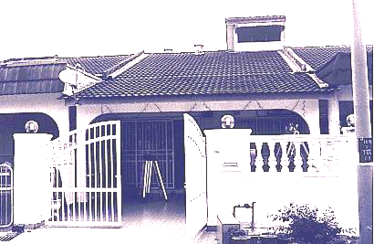
Figure 11: Single story terrace house in a row of houses (Serdang, Malaysia)
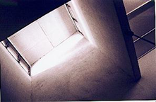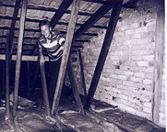
Figure 12: 1) Air-shaft in terrace house. The louvers are open at the top of the shaft for removal of hot air by natural ventilation. 2) No insulation or radiant barrier (aluminium foil) is usually found on the attic; this house is an exception (Serdang, Malaysia).

The house is built with concrete walls and with concrete beams supporting the tiled roof. The ceiling is a wooden board, which normally would not have any insulation or radiant barrier (e.g. aluminium foil) to the attic.

The terrace house has a living room, a dining room, two or three bedrooms, a kitchen and a bathroom; a basic structural sketch of the terrace house depicted above is shown here:

Figure 13: Principle sketch of terrace house; a very common residential house in Malaysia.

UPM Thermal Comfort House

A prototype of a low-energy, low-cost house has been built at the Centre for Thermal Comfort Studies, UPM. The house (the UPM Thermal Comfort House) is the last in a row of low-energy houses built by Mohd. Peter Davis at the UPM campus. The house is constructed from the building system RapidWall, which consists of pre-fabricated wall panels made from gypsum reinforced with glass-fibre. The walls are delivered in a container and the house is erected in only 10 days. Another 4 weeks are needed to finish the interior of the house. The cavities in RapidWall can be filled with insulation – this especially applies to the cathedral ceiling where RapicWall panels also have been used (see Figure 14).

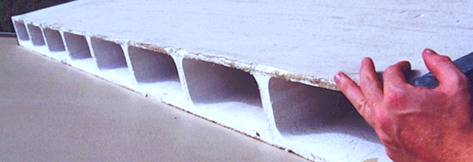
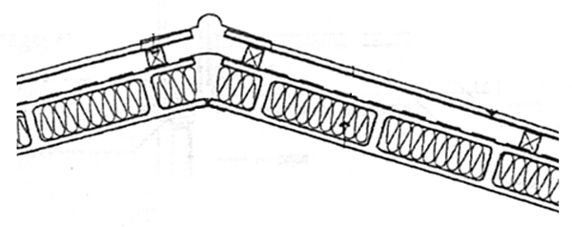
Figure 14: 1) RapidWall slab; the panels are made up to a size of 3 x 6 meters. 2) Insulated RapidWall roof. For wall panels the cavities have not been filled with insulation.

A few photos of the house are presented below:

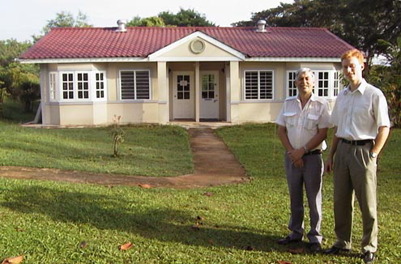
Figure 15: Mohd. Peter Davis and myself in front of the UPM Thermal Comfort House. It is a semi-detached house, i.e. a house comprising two families. (UPM, Malaysia).
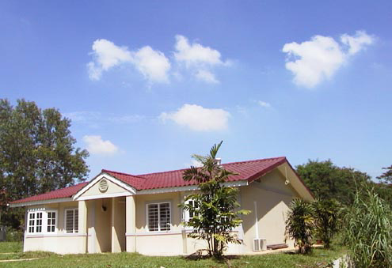
Figure 16: UPM Thermal Comfort House from the side. Each household is 60 m².

The house fulfils all the requirements for low-cost houses regarding number of rooms and living space. The floor plan below is purposely blurred for commercial reasons; the names of the different rooms will be used in subsequent chapters.

Figure 17: Floor plan of UPM Thermal Comfort House (60 m²). Reference will be made to the room names in later chapters.

Other low-cost houses
Many Malaysians live in very cheap houses that do not conform to any building standards. These houses are sometimes self-built of materials at hand (see Figure 18). The roof is typically nothing but a rusty metal sheet, which absorbs much of the sunlight. Thus, the ceiling quickly heats up causing an unpleasant indoor climate (see Figure 3, page 10). No doubt that the Malaysians deserve better solutions for low-cost houses.
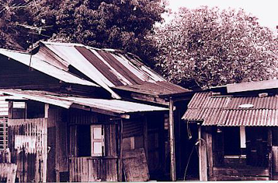
Figure 18: Low-cost houses with rusty metal sheet roofs (Melaka, Malaysia)

Malaysian Architecture
The original Malaysian houses were constructed to cope with the hot and humid climate before relying on air-conditioners. General features of the houses were elevation from the ground, high ceilings and high levels of natural ventilation. These buildings do heat up during the day, but the high ventilation ensures that they do not “overheat” and that they stay cool at night. “Cool” meaning close to ambient temperature.

The traditional Malaysian houses are not attractive in today’s urban society for a number of reasons:

- They are too expensive to build and maintain compared to concrete houses
- The openings and wooden structures make the houses easy targets for burglary
- Returning to traditional design may be considered as a step backwards for many Malaysians, who want to develop.
- Appearance is more important than functionality.

Two pictures of an original Malaysian house are brought below. The pictures were shot in Mini Malaysia, Melaka, where traditional houses from all over Malaysia are displayed.

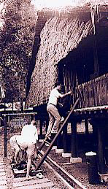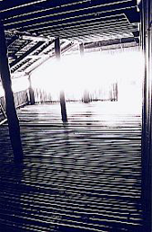
Figure 19: Traditional house from Sarawak, Malaysia. The house is placed on
stilts and is made from bamboo allowing high rate of natural ventilation.

Measurements

People in Kuala Lumpur regularly complain that the city has become hotter during the past couple of decades. This general increase in temperature is denoted as the “urbanisation effect”, and it occurs when the natural environment is transformed into city. A number of temperature measurements were taken in and around the UPM Thermal Comfort House to shed light on this phenomenon. Moreover, the measurements were used as reference for the computer simulations.

Measuring Equipment
Hobo thermocouple data-loggers the size of a matchbox were used to measure the temperature every 6 minutes. Each data-logger was calibrated; the temperature was measured with an accuracy of ±0.2°C.

The Experiment
The experiment ran for seven full days (December 9-15, 1999) at the UPM Thermal Comfort House. Information about the house utilisation and the outdoor climate during the days of the experiment is listed in Table 8, whereas Table 9 states where the temperature sensors were placed.

Table 8: Use of UPM Thermal Comfort House (used as office building) during experiment.
Date | Dec. 9 | Dec. 10 | Dec. 11 | Dec. 12 | Dec. 13 | Dec. 14 | Dec. 15
Day | Thursday | Friday | Saturday | Sunday | Monday | Tuesday | Wednesday
Use of  building | Office hours | Office hours | Office hours, afternoon free | None | Office hours. Air-con on all night in master bedroom | Office hours | Office hours
Sunny  day | Yes, but not in late afternoon | On  and off | Yes | Yes | Yes | - | -

Table 9: The name, placement and remarks to the temperature measurements at the UPM Thermal Comfort House (December 9-15, 1999).
Name | Placement | Remarks
Ambient | Sensor placed in radiation shield | 2 meters above the ground
Apron | Sensor placed with thermal contact to sunny concrete apron | The sensor was taken out of the box and was taped on top of the apron (South-East corner)
Grass | Sensor placed on sunny lawn with thermal contact to grass | The sensor was taken out of the box and placed under a big grass straw, thus avoiding exposure to direct sunlight.
Roof | Sensor placed with thermal contact to the sunny metal sheet roof | The sensor was taken out of the box and taped to the bottom side of the metal sheet roof facing South (15° inclination, thus avoiding exposure to direct sunlight.
Floor | Sensor placed in thermal contact with the floor in the living room | -
Indoor | Sensor placed in living room | 1.5 meters from the floor
Window | Sensor placed in radiation shield outside the window to the room “Bed2” | The sensor is placed approx. 1.5 meters above the apron where the measurement “Apron” is taken.
Note: Eight additional temperature measurements were taken, but they will not be discussed in this report

Results
The aim of the measurements was to shed light on the factors adding to the urbanisation effect. More specifically, temperature measurements were taken on different surfaces in the urban and natural environment for direct comparison. The same was done for air temperatures in the two environments.

Urbanisation Effect
A sure sign of urbanisation is the increased use of concrete and asphalt for houses and roads. When greenery is exposed to sunlight much of the solar energy is used for evaporation of water. For example, a full-grown tree can evaporate up to 400 litres of water pr. day (Cler et al., 1998). When sunlight hits concrete it is another story. Much of the solar heat gets stored in the thermal mass of the concrete and the heat dissipates to the surroundings throughout the night. This is clearly evident from Figure 20.

Figure 20: Average temperature measurements from outside the UPM Thermal Comfort House.
The temperature of the concrete apron never drops below the grass temperature, but stays 2 -15°C higher throughout the day and night except during the morning hours when the two temperatures equal. The considerably higher temperature of the concrete apron is indicative of the urbanisation effect (see Figure 22). Figure 20 also shows that the metal sheet roof heats up far beyond the grass temperature. However, the thin metal sheets have very little thermal capacity and cool quickly at night. In fact, they become colder than ambient temperature due to radiation to the cool night sky.
Figure 21: Higher air temperature outside window than ambient. UPM Thermal Comfort House with concrete apron.

Interestingly, the ambient temperature is always cooler or equal to the ground (i.e. apron and grass) temperature. Thus, houses should preferably be built on stilts with no thermal contact to the ground. Lifting the house off the ground will make it cooler, but the house will still be subject to the urbanisation effect through increased heat radiation from the ground and higher air temperatures. The measurements show how the hot concrete apron affects the envelope of air around the house. A temperature difference of up to 3°C is detected during the day. This will contribute to the heat transmission into the house from increased heat gains through conduction and ventilation.

Figure 22: A gradual increase in temperature is observed for an area subject to urbanisation. Precautions must be taken in projection of the trend-line; 21 years is a relatively short period by climatic standards.

Night Cooling
The UPM Thermal Comfort House employs a high ventilation rate at nigh in order to cool the interior of the house. At night the outdoor air temperature usually drops below the comfort zone of 24-28°C. Indoor air is sucked out through two ceiling exhaust fans and is replaced by cooler outdoor air drawn in through windows and ventilation grills.

For the night ventilation to be effective it is necessary for the cool night air to heat exchange with the indoor structures of high thermal mass (i.e. the concrete floor and the partitioning walls). Drawing air through the windows will not necessarily cause an effective heat exchange. Instead the outdoor air could be sucked through air channels in the floor slab and/or through cavities in the RapidWall. This would most certainly increase the heat exchange efficiency.

Another option is to use water instead of air (see Figure 23). The concept is cool the water by sprinkling it onto the roof at night. Due to night sky radiation the roof cools below the ambient temperature at night. The water is collected from the roof and channelled through pipes in the floor slab before being sprinkled onto the roof again.

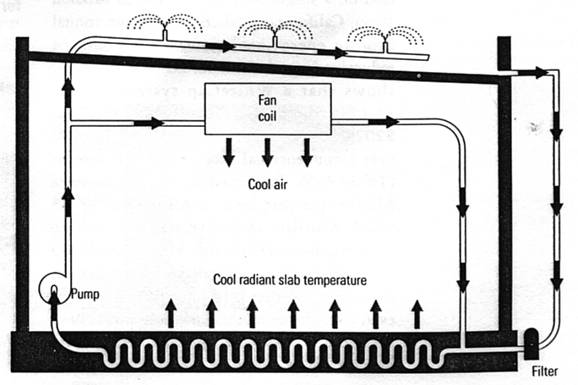
Figure 23: Night sprinkling of roof in order to cool floor slab. This system is called WhiteCabF (Cler et al., 1998).
The question is whether it is economical to build such cooling systems in Malaysia, which has small dinural temperature variations. The question will be left open for discussion; Figure 24 displays the measured temperatures inside and outside the UPM Thermal Comfort House; the roof temperature is approximately 4°C lower than the floor and walls at night.

Figure 24: Temperature difference of indoors and outdoors for the UPM Thermal Comfort House. The question whether night cooling is a good idea is left open.

Simulations and Results

Due to lack of time the simulations for this report are restricted to the UPM Thermal Comfort House. The Malaysian weather data year (TRY) for TSBI3 was only completed two weeks before the report deadline. Hence, the number of TSBI3 simulations is limited, and the results have not been thoroughly checked. A continuation of the work will be undertaken in the spring of 2000, and a report summarising the collective findings for the UPM Thermal Comfort House and the terrace house will be completed by June 2000. Three areas have been in focus for the simulations of this report:

- U-values of the roof and walls (Heat2)
- Mapping of heat gains to the indoor climate (TSBI3)
- Reduction of solar heat gain through windows (TSBI3)

Roof and Wall Simulations (Heat2)
Simulations were carried out to determine the U-values of the roof and walls of the existing UPM Thermal Comfort House; computations were also performed for a new insulated panel roof, which will be used for future houses instead of the RapidWall panel roof. The extensive input and output data are available on diskette. Table 10 and Table 11 list the thermal and surface properties of the materials used for the computer simulations, while Figure 5 and Figure 25 show the design of the two different roof systems.

Material | Conductivity  (λ)  [W/m K] | Thermal  capacity  [J/kg K] | Density  [kg/m³] | Solar  absorption
Insulation (Rockwool) | 0.037 | 848 | 50 | -
Metal sheet roof | 17 | 460 | 7820 | 0.9
Steel frame | 17 | 460 | 7820 | -
Wooden battens | 0.125 | 2500 | 450 | -
Cement board | 0.49 | 1000 | 1100 | -
RapidWall (glass-fibre  reinforced gypsum) | 0.4 | 1000 | 1300 | 0.3
Table 10: Thermal properties used in computer simulations
 | Indoor | Outdoor | RapidWall  cavity | Aluminium  foil
Surface film resistance (m² K/W) | 0.13 | 0.04 | 0.17 | 0.17
Heat radiation emissivity (ε) | 0.9 | 0.9 | 0.9 | 0.1
Table 11: Surface properties used in computer simulations


555 mm
Figure 25: 1) Cross sectional cut of steel frame roof drawn to scale. The width (shown here) is 555 mm, the length is 6000 mm, and the height depends on the level of insulation (see principle sketch below) 2) Principle sketch of the edge of the steel frame panel; the wooden battens have not been included. The conductivity of the materials are included in the parenthesis. The variables a, b, c, f and h have been used for the simulations; the results are shown in Figure 26. The value “h” denotes the ventilation rate of the air cavity below the metal sheet.

Computed U-values
The Heat2 roof simulations were steady-state simulations with a fixed indoor surface temperature of 28°C and a roof temperature of 50°C. The margin of error was set to 0.1%. The results for the steel frame roof and the RapidWall roof are found in Figure 26 and Table 12, respectively.

Figure 26: Computed U-values for different steel frame roofs using Heat2. The letter codes are explained in Figure 25; for example, the first roof “a80, b0, c50, f1, h0” is composed from a 80mm thick insulated steel frame (a80), 0mm additional insulation (b0), an air space of 50 mm (c50), an aluminium foil (f1), and with a cavity that has an air change of 0 times pr. hour (h0).

The steel frame roof is a lightweight structure. According to the Singapore recommendations the U-value should be no higher than 0.5 W/m² K (see Table 19). All of the roofs except A and B comply with this recommendation. Several interesting observations are made from Figure 26:

- Thermal bridging markedly affects the U-value. For example, Roof A and Roof C have the same amount of insulation, yet, the U-value of Roof A is 31% higher because the highly conductive steel frame penetrates the entire insulation layer. The same effect is observed for Roof F and Roof G. Note that Roof A has a bigger air cavity than Roof C, which only adds to the difference in U-value in a direct comparison.
- Usage of aluminium foil as a radiant barrier is recommendable. Roof B is identical to roof C but does not have an aluminium foil resulting in a 13% higher U-value. The aluminium foil starts to play a greater role for less insulated roofs (Please refer to U-value formulas, page 13).
- Mechanical ventilation of the air cavity under the metal sheet roof has little effect. For three identical roofs (Roof C, D and E) the air change rates were 0 hֿ¹, 3 hֿ¹ and 1000 hֿ¹, respectively. The increased ventilation rate when compared to Roof C did not have any effect for Roof D and only reduced the U-value by 13% for Roof E. The 13% energy savings will surely not outweigh the power consumption for enforcement of such a high air change. The benefits of ventilation will – similarly to the use of aluminium foil – be more outspoken for poorly insulated roof structures.
- Not surprisingly – a thicker layer of insulation decreases the U-value.

All of the above roof structures can be tested in the TSBI3 computer model for the UPM Thermal Comfort House, but due to time constraints this has not been accomplished. Only a the RapidWall roof and a pure metal sheet roof have been used for these simulations (see Table 12).

Table 12: Roof structures used in TSBI3-simulations
Name in TSBI3 | U-value  [W/m² K] | Description
Roof, metalsheet | 5.9 | Metal sheet roof on wooden battens
Roof, Rapid-air | 1.7 | Air-filled RapidWall panel, wooden battens and metal sheet roof.
Roof, RapidWall* | 0.47 | RapidWall panel with Rockwool insulation in the cavities, wooden battens and metal sheet roof
Roof, Rapid+100 | 0.22 | RapidWall panel with Rockwool insulation, additional layer of 100 mm insulation, wooden battens and metal sheet roof
* Existing roof on UPM Thermal Comfort House

A few simulations addressing the heat gain through windows were also undertaken. In one of the simulations the eaves were all increased from approx. 0.5 meters to 1.5 meters, whereas for the second simulation the light transmittance and solar heat factors were reduced by 48% for the window glazing. First, however, the simulation for the existing UPM Thermal Comfort House will be presented.

Simulation for UPM Thermal Comfort House (TSBI3)
The input data for the model of the UPM Thermal Comfort House is very extensive and will only be presented here in general terms. The input file for the model is found on diskette. The house is inhabited by a family of five with normal energy habits. Only the living-room is equipped with an air-conditioner (750 W), which is set on a thermostat setting of 28°C. Each bedroom has a ceiling fan, which runs throughout the night together with three exhaust fans for night time ventilation. The walls are made from air-filled RapidWall (U-value = 2.7 W/m² K) and the roof from RapidWall with insulation in the cavities (U-value = 0.47 W/m² K). No shading devices (trees, hills, buildings etc.) are found around the house for the simulation.

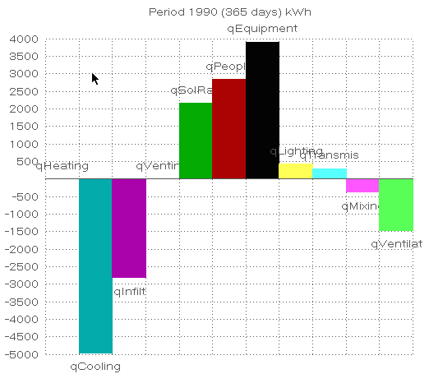
Figure 27: Annual heat balance (kWh) for UPM Thermal Comfort House inhabited by average Malaysian family of five. All the values, which are explained in Table 13, add up to zero The indoor heat removal by the air-conditioner is denoted “qCooling”; the value must be divided by the coefficient of performance (heat removal/watt) to obtain its power consumption.
Name in TSBI3 | Name in Figure 1 | Description
qHeating | Q_{m} | Heat supplied to keep the house thermally comfortable (zero for Malaysia)
qCooling | Q_{m} | Heat removed to keep the house thermally comfortable
qInfiltration | Q_{v} | Heat gain/loss by air seepage through windows and doors
qVenting | Q_{v} | Heat gain/loss by natural ventilation through open windows and doors
qSolRad | Q_{s} | Heat gain from solar radiation through windows
qPeople | Q_{i} | Heat gain from people
qEquipment | Q_{i} | Heat gain from equipment and appliances (including cooking)
qLighting | Q_{i} | Heat gain from lighting
qTransmission | Q_{c} | Heat gain/loss from conduction through building envelope (walls, roof, floor, windows and doors)
qMixing | - | Heat gain/loss from air mixing between rooms
qVentilation | Q_{v} | Heat gain/loss from mechanical ventilation of house
Table 13: Explanation of output names in TSBI3, Figure 27.

Figure 27 shows that the majority of annual indoor heat gain stems from the use of electrical equipment (primarily from cooking) and by heat emission from people. Solar radiation through windows only comes in third. Heat transmission through the building envelope is virtually zero, however, this is not surprising as the indoor temperatures on average are rather close to the average outdoor temperature of approx. 28°C (see Figure 28). For a fully air-conditioned house the net heat transmission heat gains would be considerably higher, and at the same time cooling contributions from the ventilation and infiltration would approach zero. The heat removal by ventilation (1500 kWh/year) happens on the expense of power consumption for fans (500 kWh/year). The same cooling effect could have been obtained for a little less energy by using the air-conditioner.

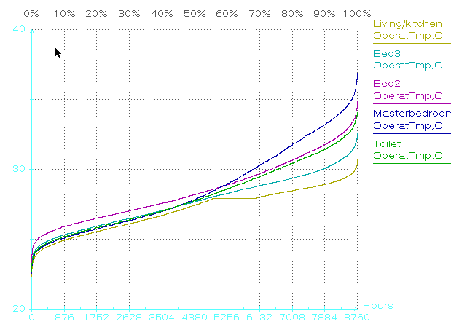
a
b
c
d
e
a
b
c
d
e
Figure 28: Statistic for annual temperatures in the respective rooms of the UPM Thermal Comfort House. The bedrooms are primarily hot (above 28°C) during the day when they are not in use.

The annual temperature profiles in Figure 28 show that the temperatures in the three bedrooms and toilet frequently exceed the maximum limit of the thermal comfort zone 28°C; the living room performs better due to the air-conditioner and virtually never exceeds 30°C. A closer look at the daily temperature profiles for each room reveals that the bedrooms only heat up during the day (when they are unoccupied) and stay cool at night. Thus, the violations of the thermal comfort zone in Figure 28 are not as bad as they look (see Figure 29).

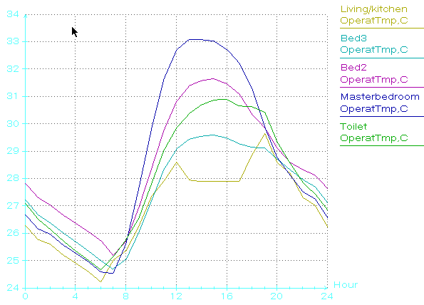
a
b
c
d
e
a
b
c
e
d
Figure 29: Typical daily temperature profile for the UPM Thermal Comfort House. The bedrooms get hot during the day but drop within the thermal comfort zone of 24-28°C around bedtime 23 O’clock until 9 O’clock in the morning.

Roof-simulations in TSBI3
The UPM Thermal Comfort House has been simulated for the four different roof structures listed in Table 12. To make the simulations comparable each room was equipped with an air-conditioner with sufficient cooling capacity to keep the room within the thermal comfort zone of 24-28°C. Figure 30 shows what effect it would have on the annual energy consumption to change from the existing RapidWall roof panel filled with Rockwool insulation to any of the three other roof types.

Figure 30: TSBI3 simulations for different roof structures with the existing insulated RapidWall roof as the reference.
The cooling demand skyrockets if only plane metal sheet roof is used. Removing or adding 100mm Rockwool insulation to the existing RapidWall roof has minor effect (≤10%) on the cooling demand. This is due to a relatively high thermostat setting of 28°C, which is close to the average outdoor temperature. For buildings with lower indoor temperature (e.g. office buildings) the level of insulation will play a greater role, as the heat flow primarily will be one way, namely outdoors to indoors.

Simulations for Solar Heat Gain
The facade of the UPM Thermal Comfort House faces directly South. This prevents the morning and evening solar radiation at low inclinations to enter through the windows at the facade and back of the house; no windows are found in the end gable walls facing East and West. However, a considerable amount of solar radiation does pass through the windows (see Figure 27). This is partly due to the small eaves (especially for the bay window in the master bedroom) and partly due to the high transmittance (83%) of the windows. Two methods for cutting down the solar heat gain are shown in Figure 31.
Figure 31: TSBI3 simulations for reduction of solar heat gain; the effect on the annual cooling load is also shown. To make the simulations comparable each room was equipped with an air-conditioner with sufficient cooling capacity to keep the room within the thermal comfort zone of 24-28°C
Both of the measures in Figure 31 provide reductions in solar heat gain as well as the cooling. Care must be taken when interpreting the results as both measures will reduce the amount of daylight indoors. This will increase the demand for artificial lighting, which to a certain extend will replace the solar heat gain (each fluorescent lamp contributes with 40 W). Moreover, the additional use of artificial lighting will add to the electricity bill - daylighting will not. The use of window coatings and big eaves are therefore best used either for windows experiencing much direct sunlight and/or for windows in rooms that have a small lighting requirement during daytime. For the UPM Thermal Comfort House this especially applies to the big window in the master bedroom, but more simulations are needed to confirm this recommendation.

Recommendations and Future Work

The major accomplishment of this report is the construction of a Malaysian TRY (Test Reference Year), which can be used for annual energy building simulations in TSBI3 and other computer programs employing climatic data. The TRY is constructed from 21 years of hourly weather data from Subang Meteorological Station. It is recommended that the validity of TRY is checked and approved by and experienced weatherman.

A few TSBI3-simulations have been undertaken for the UPM Thermal Comfort House. The simulations revealed that the three main contributors to the indoor heat gain are 1) use of equipment, primarily cooking 2) heat emission from people, family of five 3) solar radiation through windows. The annual power consumption for cooling and night ventilation was 1500 kWh and 500 kWh, respectively.

More simulations are needed in order to give specific recommendations for alteration of the UPM Thermal Comfort House. The preliminary simulations show that the house performs well to the Malaysian climate. For example, the two biggest heat contributions to the interior of the house do not relate to the house design but rather to the presence of people and their usage of equipment. However, there seems to be a potential for reduction of solar heat gain – especially in the bedrooms. Moreover, the night ventilation can probably be optimised.

This report has only scratched the surface of the simulation work for the UPM Thermal Comfort House. More simulations and in depth analysis will be presented in a new report in June 2000. The report will also include simulations for the terrace house presented in this report.

List of Abbreviations

DANCED | Danish Corporation for Environment and Development
DUCED | Danish University Corporation for Environment and Development
Heat2 | Computer program for numerical heat flow calculations
TRY | Test Reference Year
TSBI3 | Computer program for energy simulations in buildings
UPM | Universiti Putra Malaysia

References
Andersen, B., S. Eidorff, L. Hallgreen, H. Lund, E. Pedersen, S. Rosenørn and O. Valbjørn (1986). Danish Test Reference Year, TRY. Thermal Insulation Laboratory, Technical University of Denmark.

Cler, G., M. Shepard, J. Gregerson, D.J. Houghton, L. Fryer, J. Elleson, B. Pattnson, W. Hawthorne, L. Webster, J. Stein, D. Davia and Steve Parsons (1998). Commercial Space Cooling and Air Handling: Reducing Cooling Loads. E Source Inc., Boulder, Colorado, USA, pp. 3.7.

Davis, M. P. (2000). Lecture notes for guest lecture at Veterinarian Faculty, Universiti Putra Malaysia, January 3, 2000.

Davis, M.P. (1998). Energy Efficient Buildings. Building Information Centre, Petaling Jay, Selangor, Malaysia. April 8, 1998.

Erbs, D.G., S.A. Klein and J.A. Duffie (1982). Estimation of the diffuse radiation from hourly, daily, and monthly- average global radiation. Solar Energy 28(4), pp 293-302.

Fanger, P.O. (1992). Indoor Climate. In: Varme- og Klimateknik, Grundbog, 1. udgave, 2 (H.E. Hansen).Danvak Aps, pp 17-40.

Fauzi, Mohd. Ismail (1999). Advancement of Materials/Technologies for Energy Efficient Design Seminar on Energy Efficiency in Buildings. SIRIM Seminar, 27 October 1999, Shah Alam, Selangor, Malaysia.

Fong, Tian Yong (1999). Director of Building Control, Ministry of Housing and Local Government, Malaysia. Presentation given at the seminar: Proposed Energy Efficiency & Renewable Energy Provisions in the Uniform Building By-Laws (UBBL). Hotel Nikko, Kuala Lumpur, 25 October 1999.

Jeppesen, H., N. Mossin, T. Nørgård, G. Reimann and R. Schmidt (1999). Low-energy, Low-cost Bungalows in Malaysia. DUCED-report, spring semester 1999. Institute of Technology and Social Studies, Roskilde University Centre (RUC).

Kannan, K.S. (1999). Presentation given at the seminar: Proposed Energy Efficiency & Renewable Energy Provisions in the Uniform Building By-Laws (UBBL). Hotel Nikko, Kuala Lumpur, 25 October 1999.

Koenigsberger, Ingersoll, Mayhew and Szokolay(1973). Manual of Tropical Housing and Building. Part 1: Climatic Design. Longman Inc., New York.

Loke Chaw Liang (1999). Thermal Comfort of Medium and Low Cost Double Story Linked Houses in Seri Kembangan, Selangor Darul Ehsan. Faculty of Human Ecology, University Putra Malaysia, pp 60.

Longhi, F. (1999). Presentation given at the seminar: Proposed Energy Efficiency & Renewable Energy Provisions in the Uniform Building By-Laws (UBBL). Hotel Nikko, Kuala Lumpur, 25 October 1999.

Mills, A. F. (1992). Heat Transfer, International Student Edition. R.R. Donnelley & Sons Company, USA.

Normstyrelsens Publikationer (1986). Dansk Standard DS418, 5th edition. Teknisk Forlag A/S, Copenhagen, Denmark. 1986.

Parker, Callahan and Sonne (1999). Development of High Efficiency Ceiling Fan. Florida Solar Energy Center, FSEC-CR-1059-99, On-line publications: http://www.fsec.ucf.edu/~bdac/prototype/cfan.htm

Rode, Carsten (1998). Fugttransport. Opstilling af regneark til beregning af fugtdiffusion efter Glasers metode. Undervisningsnotat U-022. Department of Buildings and Energy, The Technical University of Denmark, pp 1-11.

Singapore Building Regulations (1999). Handbook on energy conservation in buildings and building services. The Development & Building Control Division (P.W.D) Singapore. pp.15.

Zain-Ahmed, A., Sayigh, A.A.M. and Othman, M.Y (1997). Field Study on the Thermal Comfort of Students in an Institution of Higher Learning. International Symposium on Advances in Alternative & Renewable Energy, The Puteri Pan Pacific Hotel, Johor Bahru, Malaysia, 22-24 July 1997. pp 550-557.

Zain-Ahmed, A. (1998). Model Year Climate for the Klang Valley, Malaysia. Seminar on Advances in Malaysian Energy Research, pp. 78-92.

Attachments
1. | Project Diary (September 7, 1999 – January 14, 2000)
2. | Seminar Program: “Environment Friendly Townships”, UPM, January 31, 2000.
3. | Erbs’ estimation model for diffuse radiation
4. | Normalised values for selection of months for TRY

Internal heat gain stemming from electric appliances essentially corresponds to electric heating, which usually is more expensive than alternative sources of heating (e.g. district heating and natural gas). Hence, maximising internal electrical heat loads is not an economical way of heating a house, however, the electrical energy is not wasted either.
The energy habits of the house residents has no influence on the labelling of “low-energy houses”; however, the energy habits has a significant influence on the overall energy consumption of the household.
Source: Guest lecture given at The Technical University of Denmark, 1998. The study was undertaken in Germany in a number of identical low-energy houses, but I do not recall the name of the study.
The life span is typically set to be 50 years.
The indoor temperature must be in the interval 23-27°C with a maximum relative humidity of 75%.
Professor at Technical University of Denmark. (Centre for Indoor Climate Studies).
Studies by Humpreys (England) and Abdulmalik (Malaysia). The studies have not been read by the author, but they are often referred to in literature concerning thermal comfort.
The studies of Abdulmalik, METP (Ministry of Energy, Telecoms and Posts), Brooks and ASHRAE are taken from another paper: (Zain-Ahmed, 1997).
Heat flow per unit area perpendicular to the flow direction
Heat2 has two types of air cavity calculations. One requires detailed entering of information regarding emissivity of surface walls, surface film resistance, ventilation rate of cavity etc., and is called “Hole (ventilation + radiation)” under the menu input > modification types. The other air cavity type is more simple assuming zero ventilation and surface emissivity of 0.9; it is called “Frame cavity” in the material library.
TSBI3 calculates the U-value for the building elements, but does not take thermal bridging into account. Thus, it is recommendable to refine the U-value calculations using Heat2.
Internal heat loads: people, lighting, equipment etc.
Annual hourly data for solar radiation, ambient temperature, relative humidity, wind speed, wind velocity and cloud cover.
For more information about TSBI3 and a price list go to http://www.sbi.dk/English/Publishing/Software/
The values are integrated over a period of one hour, but the exact time interval has not been specified.
Diffuse solar radiation is measured on a horizontal surface.
Direct solar radiation is measured on a horizontal surface.
Beam solar radiation is measured on a surface perpendicular to the radiation.
Including the month in the statistical computations will influence the total average and mean values, which should be calculated from as many months as possible.
According to the 8th Malaysian Plan: 800,000 houses built over 5 years, 90% of houses should be low-cost.
A lesson learnt from the UPM Thermal Comfort House is that RapidWall panels are impractical as roof panels. Thus, a different insulated roof will be used in the future.
An example of this is an advertisement for window film coatings, which are sold on the catch line: “Make your home or office look better”. The advertisement explains that the coating will “provide the look of expensive tinted glass”. The energy benefits of the coating only come in second.
The additional measurements were primarily taken indoors and are available.
Talking from experience models typed into TSBI3 usually contain some faulty entering of data. Basic checks have been performed and the simulation results seem sensible. However, a thorough check of the model ought to be undertaken.
If the diskette is not enclosed contact the author.
If the diskette is not enclosed contact the author.
Air-conditioner information: National CS/CU-90KH, 750 Watts, cooling capacity of 2550 Watts. The efficiency is 11.6 (Btu/h)/W.
For the air-conditioner used at the UPM Thermal Comfort House the coefficient of performance is 3.4. This gives an annual power consumption of 4955 kWh / 3.4 ≈ 1500 kWh.
The UPM Thermal Comfort House air-conditioner has a coefficient of performance of 3.4.
TSBI3 is able to calculate the amount of light (lux) in each room. The program can be asked to switch on the artificial light when the lux falls below a specified level. Hence, computations for how window coatings and/or bigger eaves affect the utilisation of artificial lighting are feasible.

